**PROJECT REPORT**

**ON**

**IIPS COUNSELING PORTAL**

Dissertation Submitted in Partial fulfillment of the

Requirement for the Award of the Degree of

*Master of Technology (Information Technology)*

Semester VI

***Session Jan – May, 2012***

**Guided By Submitted By**

Mrs. Yasmin Shaikh Ashwini Varma (IT-2K9-07)

Keshav Patidar (IT-2K9-20)

Prathmesh Dubey (IT-2K9-29)

**International Institute of Professional Studies**

**Devi Ahilya Vishwavidyalaya, Indore, M.P.**

**2012**

**DECLARATION**

We hereby declare that the project entitled “IIPS Counseling Portal“which is submitted by us for the partial fulfillment of the requirement for the award of Master of Technology (Information Technology) 5 ½ Years VI Semester to International Institute of Professional Studies, Devi Ahilya Vishwavidyalaya, Indore, comprises our own work and due acknowledgement has been made in text to all other material used.

Signature of Students

Ashwini Varma:

Keshav Patidar:

Prathmesh Dubey:

Date:

Place:

**CERTIFICATE**

It is to certify that we have examined the dissertation on “IIPS Counseling Portal”, submitted by Ms. Ashwini Varma, Mr. Keshav Patidar and Mr. Prathmesh Dubey to the International Institute of Professional Studies, DAVV, Indore and hereby accord our approval of it as a study carried out and presented in a manner required for its acceptance in partial fulfillment for the award of the degree of “Master of Technology (Information Technology) 5 ½ Years VI Semester”.

**Internal Examiner                                                                               External Examiner**

Signature**:** Signature**:**

Name  **:**Name**:**

Date        **:** Date   **:**

**ACKNOWLEDGEMENT**

Firstly, I must thank to the almighty GOD. This work is result of inspiration, support, guidance, cooperation and facilities that were extended to us at their best and at the most by Persons at all levels and we are indebted to all of them.

We acknowledge our sincere thanks to those who have contributed significantly to this project. It is a pleasure to extend deep gratitude to **Dr. R.K. Vyas**, Director IIPS and **Dr. B.K. Tripathi**, Ex-Director IIPS and **Mrs. Kirti Mathur**, Head Computer Programs for their valuable guidance and support. We especially thank our project guide and manager **Mrs. Yasmin Shaikh** for the helpful solutions and comments enriched by her experience and also for pointing out mistakes and shortcomings from time to time, which will go a long way in completing the project.

We also extend our thanks to our most beloved Parents because of whom we exist and because of whom we are what we are today. We also thank our batch facilitators **Mr. Nitin Nagar** and **Mr. Rahul Singhai** for their unending support and belief, which motivated us enormously in completion of this project. Last but not least, we are thankful to all colleagues and friends for their cooperation and encouragement at every stage of this project.

|  |  |  |
| --- | --- | --- |
| **Ashwini Varma**  **IT-2K9-07**  **IIPS-DAVV,Indore** | **Keshav Patidar**  **IT-2K9-20**  **IIPS-DAVV,Indore** | **Prathmesh Dubey**  **IT-2K9-29**  **IIPS-DAVV,Indore** |

**TABLE OF CONTENTS**

|  |  |
| --- | --- |
| **Topic** | **Page No.** |
| Cover Page  Declaration  Certificate  Acknowledgement  Table of Contents  List of Figures  List of Tables   1. Abstract    1. Abstract 2. Introduction    1. Introduction    2. Objectives       1. Business Goals and Objectives       2. Project Goals and Objectives    3. Assumptions 3. System Analysis    1. Working of Existing System    2. SRS Document       1. Product Overview       2. Purpose       3. Scope       4. Functional Requirements       5. Non Functional Requirements          1. Static Requirements          2. Dynamic Requirements          3. Capacity Requirements    3. Hardware Requirement    4. Software Requirement    5. Gantt Chart    6. Information Gathering    7. Feasibility Analysis       1. Economical Feasibility       2. Technical Feasibility       3. Behaviour Feasibility    8. Risk Analysis    9. Technology   3.10. Scope of the Project  3.11. Team Structure   1. IIPS Counseling Portal    1. Proposed System As Solution    2. Project Justification 2. System Design    1. Logical Design    2. Data Flow Diagram       1. Level 0 Data Flow Diagram       2. Level 1 Data Flow Diagram    3. Entity Relationship Diagram    4. Physical Design       1. Overview       2. Physical Database Design Process    5. Physical Data Model    6. Input Output Design    7. User Interface Design 3. Testing and Implementation    1. Test Plan    2. Test Criteria    3. Software Quality Assurance    4. Screen Shots 4. Conclusion    1. Conclusion 5. Bibliography    1. Books and Manuals    2. Web Resources | 1  2  3  4  5 – 8  8  9  10 – 11  11  12 – 15  13  14 – 15  14  15  15  16 – 31  17  18 – 24  18  18  19 – 20  20 – 22  23 – 24  23  23 – 24  24  25  26  27  28  28 – 29  28  28  29  29 – 30  31  31  31  32 – 34  33  34  35 – 48  36  37 – 38  37  38  39 – 40  41 – 43  41  42 – 43  44 – 47  48  48  49 – 68  50 – 51  51  52  53 – 68  69 – 70  70  71 – 72  72  72 |

**LIST OF FIGURES**

|  |  |
| --- | --- |
| **Figure** | **Page No.** |
| 1. Gantt Chart 2. Level 0 Data Flow Diagram 3. Level 1 Data Flow Diagram 4. Entity Relationship Diagram 5. Entity Relationship Diagram 6. Login Entity 7. Login Table 8. Cet_Student Table 9. Rank Table 10. Attendance Table 11. Document Table 12. Course Table 13. Fees Table 14. Seats Table | 27  37  38  39  40  40  44  44  45  45  46  46  46  47 |

**LIST OF TABLES**

|  |  |
| --- | --- |
| **Table** | **Page No.** |
| 1. Functional Requirements 2. Gantt Chart | 20 – 22  27 |

**ABSTRACT**

This project involves creation of counseling portal for International Institute of Professional Studies (IIPS). The counseling portal consists of four phases.

* Phase 1 : Attendance
* Phase 2 : Document Submission
* Phase 3 : Course Selection
* Phase 4 : Fees Submission

Students have to clear these phases to reach next phase. For example, Student can be allowed to submit documents only if he is present; student can be allowed to select course only if he has successfully submitted his documents; student can be allowed to submit fees only if he has selected course. If student has cleared all the phases his admission is confirmed and the seat is allotted.

So in this project, we have made 6 web pages. First for user authentication, second for attendance, third for document submission, fourth for course selection, fifth for fees submission and sixth for seats details.

**INTRODUCTION**

This project involves creation of counseling portal for International Institute of Professional Studies (IIPS). International Institute of Professional Studies is a autonomous educational institute situated in Indore. It is affiliated to Devi Ahliya Vishwa Vidyalaya (DAVV) University. The most part of the counseling process was earlier done manually and was time consuming, we through our project aims at reducing the manual job to negligible and make the counseling process automated and provide the counseling staff more fast, secure and reliable environment to work upon.

**OBJECTIVES**

1. **Business Goals and Objectives :**

The business goals and objectives for this project will focus on implementing counseling process that:

* Enhances the ability and effectiveness of staff to perform their jobs.
* Facilitates coordination and information sharing between counseling staff and students in counseling process.
* Less time consuming.
* Provides good interface for counseling staff which make him/her understand the software easily.
* Enhances data security and integrity.
* Facilitates the electronic capture of data.
* Is easy to use.
* Eliminate redundant data entry.
* Stores data electronically for future use.

1. **Project Goals and Objectives :**

* Ensure that counseling staff inputs into the design process.
* Accomplish project business goals and objectives within time parameters.
* Provide security constraints like login page to ensure unauthorized access to data.
* Provide facilities for prevention against some hacking techniques like SQL injection, etc.
* To imbibe the beauty of PHP and MySQL but at the same time makes it user friendly for people unaware of its functionalities.
* To provide dynamic linking between web pages.
* Analyze whether the project is feasible in terms of technology, human resource and cost.
* Develop a plan for project execution.

**ASSUMPTIONS**

The assumptions for the project are:

* CET result database should be provided in advance.
* The systems on which the software has to be used should have to be P-4 compatible machine with minimum of 512MB of free space in the Hard disk and a 256MB RAM.
* The counseling staff should have some basic knowledge in operating computers.

**WORKING OF EXISTING SYSTEM**

The current system used for IIPS Counseling consists of mainly manual work. This was basically paper work process. It was a headache to deal with problems like data duplication or data collision.

Limitations of the current system are as follows:

* Since the system is mainly manual, so there is probability for manipulation and error due to carelessness. For example, if a student is unable to fulfill the criteria of 50% in 10th and 12th standard, but due to carelessness of counseling staff, his/her documents are submitted which could possibly cause big problem.
* No backups of the records are maintained due to tedious nature of the work. This might lead to loss of data in case of calamities like fires, etc.
* The manual system is not consistent in nature.
* Searching for particular records is very difficult task.
* No recovery of data by any means if it gets lost.
* The records for each student are to be checked at every phase of counseling. For example, if student is absent then also its name will be called for document submission, course selection and fees payment.
* To maintain all the records a large amount of money is required every year.

**SRS DOCUMENT**

1. **Product Overview**

This Software Requirements Specification provides a complete description of all the functions and specifications of the International Institute of Professional Studies (IIPS) Counseling Portal needed by software engineers to adequately design and implement the software. Software Requirements Specification (SRS) completely describes all of the functions of a proposed system and the constraints under which it must operate.

1. **Purpose**

IIPS Counseling Portal is intended to simplify the complex counseling process by performing most part of the faculties job automatically and hence, reducing the work load of the faculties. This document is meant to delineate the features of IIPS Counseling Portal, so as to serve as a guide to the developers on one hand and a software validation document for the prospective client on the other.

The expected audiences of this document are the faculties of IIPS, mainly the project guide Mrs. Yasmin Shaikh and the faculties who will use this system (Counseling Attendance Incharge, Document Submission Incharge, Course Selection Incharge and Fees Submission Incharge) and the software developers.

1. **Scope**

In Scope:

* User Authentication.
* Facility to take Attendance.
* Facility to sort students on the basis of their ranks (like if all, All India Seats are occupied then we can sort students on the basis of their MP Rank. So, this reduces time as all those students who are not of MP will be skipped even if their ranks are better than MP student’s ranks as there are no seats left for them).
* Facility to make document submission procedure very easy in which eligibility criteria (like 10th and 12th percentage should be greater than 50%) are automatically checked and also provides facility for required modifications in case of non submission of optional documents (like if any reserved category student is unable to show its caste certificate, his category should be automatically changed to General, etc).
* Facility to perform course selection procedure.
* Facility to perform fees submission procedure.
* Facility to dynamically link web pages i.e. the response of one web page is used by the other web page (like if the student is present then only he/she can go for document submission).
* Facility to show seats status to students i.e. how many and which seats of which course are available.

Out of Scope:

* Facility to edit the details of the students i.e. if some details of student (like name, score, rank, etc.) are wrong so, it cannot be edited using this software.
* Facility to modify the data already entered (like if a student tells to choose MCA as course and the course selection incharge has submitted his choice and later he/she changes his mind and wishes to opt for M.Tech, then it cannot be done, he/she will be allotted MCA seat only).
* Any information related to the scholarship is not included in this software.

**4. Functional Requirements**

There are mainly seven functions to be employed in this project:

|  |  |
| --- | --- |
| Function | Purpose |
| User Authentication | This function will prevent the portal from unauthorized access. Moreover, this function will help to redirect the authorized personnel’s to their respective field of work. For example, if Attendance Incharge logs in with his/her username and password then he/she will be redirected to the web page designed for attendance purpose and in case of Document Submission Incharge he/she will be redirected to the web page designed for document submission purpose and so on. |
| Attendance | This function will be used by Attendance Incharge. This function will enable Attendance Incharge to take the attendance of the students. This function will also contain feature to sort students on the basis of their ranks (like if all, All India Seats are occupied then we can sort students on the basis of their MP Rank. So, this reduces time as all those students who are not of MP will be skipped even if their ranks are better than MP student’s ranks as there are no seats left for them). |
| Attendance Search | This function will also be used by Attendance Incharge. This function will enable Attendance Incharge to modify the attendance of the students whose attendance has already been marked. This function is useful when a student gets late for the counseling process. If the student gets late and his/her attendance has been marked as “Absent”. This webpage will enable Attendance Incharge to change the attendance of the student from “Absent” to “Present” using his/her Roll Number. |
| Document | This function will be used by Document Submission Incharge. By using this function, Document Submission Incharge will check whether the student has all the documents or not. If student is unable to present mandatory documents (like 10th Mark sheet, 12th Mark sheet, Transfer Certificate, Migration Certificate), then this web page will not allow Document Submission Incharge to accept the documents of the student, in that case document submission incharge will have to reject the documents of the student. If student is unable to present optional documents (like MP Domicile, Caste Certificate) then Document Incharge can accept the documents but required actions will be performed automatically (like if any reserved category student is unable to show its caste certificate, his category should be automatically changed to General). |
| Course | This function will be used by Course Selection Incharge. This function enables Course Selection Incharge to submit the course selected by the student and to notify if seat for that course is not available so that student can choose other course. This web page should also provides facility to reject the admission of student in case student did not get his/her desired course. |
| Fees | This function is used by Fees Submission Incharge. This function enables fees submission incharge to accept the admission if the student pays fees and to reject the admission if the student is unable to pay fees. |
| Seats | This function will not require user authentication. It will be available to all personnel’s as well as students. This function will show the status of seats i.e. how many and which seats of which course are available. |

Table 1. Functional Requirements

**5. Non Functional Requirements**

**5.1 Static Requirements**

The requirements that do not impose constraints on the execution characteristics of the system are considered as static requirements. It includes requirements as:

* Number of terminals to be supported : Six
  + One Server.
  + Four Terminals for Incharge.
  + One Terminal for showing seats information to the students.
* Number of simultaneous users to be supported : Five
  + All except for Server.
* Number of files that the system has to process and their sizes:
  + Each terminal has to process only one file at a time.
  + The server has to process around six to nine files at same time.
  + Each file size will range from 300KB to 2MB.

**5.2 Dynamic Requirements**

Specify constraints on the execution behavior of the system. It includes requirements as:

* Response Time: Response time will depend on the speed of Server and speed of Internet. More the speed of Server and Internet less will be response time, which results in more effective and fast working of our system. So, there is no need to put constraints on the Response Time of the system.
* Throughput constraints: Since, the data passing through the system will be of only few Kilo bytes. So, there is no need for applying any constraints on the data passing through the system.

**5.3 Capacity Requirements**

* Number of simultaneous users, processing requirements for normal and peak hours, static storage capacity:
  + One Server
  + Five Simultaneous Users
    - Four Incharge.
    - One for showing the seat information to the students.
  + For this software, normal and peak hours are same. The processing requirement are as follows:
    - The terminals should be of at least Pentium 4.
    - The terminals should have minimum of 256MB RAM. 1GB is optimum RAM for the terminals.
    - Server should have at least 1GB of free space while other terminals should have at least 512MB of free space. As all the data is stored on server. Only few Kilo bytes of data are retrieved from the server on the terminal.
* System priorities for user and functions
  + All the terminals of incharge should get equal priority.
  + And the terminal showing seat information to the students should get less priority.

**HARDWARE REQUIREMENT**

Although we recommend the use of the best hardware available but the minimum requirement is as follows:

* Six Personal Computers with
  + 333MHz Pentium 4 Processor
  + 256 MB RAM
  + 512 MB Free Hard Disk Space
  + 40 GB Hard Disk Space

Optimum Hardware Requirements are as follows:

* Six Personal Computers with
  + 2 GHz Intel Core 2 Duo Processor
  + 1 GB RAM
  + 1 GB Free Hard Disk Space
  + 40 GB Hard Disk Space

**SOFTWARE REQUIREMENT**

Although we recommend the use of the best hardware available but the minimum requirement is as follows:

* Windows XP
* Adobe Dreamweaver
* WampServer
  + PHP (Server Side Scripting Language)
  + MySQL (Relational Database Management System)
  + Apache HTTP Server (Web Server)
* JavaScript, AJAX and Flash enabled Web browser

Optimum Software Requirements are as follows:

* Windows 7
* Adobe Dreamweaver CS5
* Latest Version of WampServer
  + PHP (Server Side Scripting Language)
  + MySQL (Relational Database Management System)
  + Apache HTTP Server (Web Server)
* Latest Version of Google Chrome (JavaScript, AJAX and Flash enabled Web browser)

**GANTT CHART**

IIPS Counseling System Project Schedule

Due Date: April 20th, 2012

|  |  |  |  |  |  |  |  |  |  |  |  |
| --- | --- | --- | --- | --- | --- | --- | --- | --- | --- | --- | --- |
| Task | % Complete | Status | Dates | | | | | | | | Duration |
| 25 Jan | 1 Feb | 10 Feb | 1 Mar | 15 Mar | 25 Mar | 10 Apr | 15 Apr |
| II | 100 | C | S | E |  |  |  |  |  |  | 7 days |
| FS | 100 | C |  | S | E |  |  |  |  |  | 10 days |
| SA | 100 | C |  |  | S | E |  |  |  |  | 20 days |
| LD | 100 | C |  |  |  | S | E |  |  |  | 15 days |
| PD | 100 | C |  |  |  | S |  | E |  |  | 25 days |
| I | 100 | C |  |  |  | S |  |  | E |  | 40 days |
| T | 100 | C |  |  |  |  |  |  | S | E | 5 days |
| D | 100 | C |  |  |  |  |  |  | S | E | 5 days |

Figure 1. Gantt Chart

|  |  |  |  |
| --- | --- | --- | --- |
| **Symbol** | **Meaning** | **Symbol** | **Meaning** |
| II | Initial Investigation | FS | Feasibility Study |
| SA | System Analysis | LD | Logical Design |
| PD | Physical Design | I | Implementation |
| T | Testing | D | Debugging |
| C | Completed | AS | After Schedule |
| OS | On Schedule | S | Start Date |
| E | End Date |  |  |

Table 2. Gantt Chart Symbols

**INFORMATION GATHERING**

Information gathering was done by analyzing previous manual process of counseling and consulting IIPS Faculties (Counseling Staff) about the various management techniques and requirements of the process of counseling.

**FEASIBLITY ANALYSIS**

The most successful system projects are not necessarily the biggest or most visible in a situation but rather those that truly meet user’s expectations. To analyze the project’s feasibility is evaluated on the following grounds:

1. **Economic Feasibility**

As far as the benefits of the project are concerned the cost is quite negligible. The main cost is of the system used to access this project. But that does not concern us as the systems that are used to access the project are already available in IIPS Computer Lab. Hence, this project is economically feasible.

1. **Technical Feasibility**

This project is technically feasible as it has got all features necessary to form a healthy environment for communication. The concepts and technology used in this project are perfectly well and secure. Any user having basic computer knowledge can access this project and make full use of it.

1. **Behaviour Feasibility**

People are inherently resistant to change, and computers have been known to facilitate change. An estimate should be made of how strong a reaction the user staff is likely to have towards the development of the computer system. It is common knowledge that computer installations have something to do with the turnovers, transfers, retaining and changes. But since the Counseling Staff of IIPS is familiar with the basic use of computers and since this project is being made on the basis of requirements of Counseling Staff only, so this project implementation will not hamper the environment and the working of the IIPS Counseling process or Counseling Staff.

**RISK ANALYSIS**

Though a lot of care has been given to restrict the malicious inputs to the software but it is recommended to provide the correct and valid inputs. Moreover, most of the inputs are taken in form of the options (radio buttons, combo box or check box) for accurate data entry, whose description will be there at the time of their use but it requires a little patience to read those options before selecting them. At last, one should take care of the minimum hardware requirements whose absence may lead to unpredictable results.

The various risks associated with the project are:

* The user is not efficient in the use of computers.
* The system crashes due to some reason like sudden power failure.
* Various malicious codes like Viruses, Trojans and Spywares can also cause problem to the project.
* The data entry is not compatible with the requirement. Wrong entries will make the project failure.

Measures taken to avoid the risks are:

* Since Counseling Staff is familiar with the basic knowledge of computers so the project will remain in trained hands.
* Necessary backups are made regularly by software itself.
* It is recommended to use antivirus programs and firewalls to protect computer from viruses.
* Necessary warnings are given whenever incompatible data entry is made by the user.

**TECHNOLOGY**

The following technology has been used in the creation of this project:

* Server Side Scripting : PHP
* Relational Database Management System : MySQL
* Web Designing : HTML and CSS
* Browser Side Scripting : JavaScript and AJAX
* Implementation Software : Adobe Dreamweaver

**SCOPE OF THE PROJECT**

This project is possible to implement in the light of workability, meeting user’s requirements, impact on organization (IIPS) and effective use of resources. This project has scope in all the educational institutes where the counseling process is hectic, error prone and time consuming.

**TEAM STRUCTURE**

The project team consists of:

* Ashwini Varma (IT-2K9-07)
* Keshav Patidar (IT-2K9-20)
* Prathmesh Dubey (IT-2K9-29)

**PROPOSED SYSTEM AS A SOLUTION**

The following points will give an overview of the proposed system:

* The proposed system will be a completely automated system which will control entire operability of the IIPS Counseling process.
* The system will generate appropriate reports.
* All limitations of the present system will be removed to make the system more efficient.
* The system will build in such a way that it avoids data redundancy.
* The system will provide backup plans to avoid data loss that is of high priority.
* It will be scalable so that in near future the system can be expanded.
* The system will provide search facilities to find a specific entry from the database.
* The system will be reliable enough to perform in adverse conditions.
* The system will fulfill all necessary requirements of the end user as much as possible.
* The system will provide an error free environment.
* The system will provide a user-friendly interface with a realistic view.
* The system will provide a detailed help and user manual to assist the end user.

**PROJECT JUSTIFICATION**

The aim of the proposed system is to address the limitations of the current system. The requirements have been gathered from feedback obtained from the IIPS Counseling Staff. They are also based on the requests and defects recorded in the past. Following is the justification for the proposed system:

* Reduce data duplication by use of RDBMS.
* Implement validation techniques and checks that will help reduce the margin of error in operations.
* Provide adequate data backup facilities in order to ensure system restart even after a calamity.
* Since the system will be a RDBMS, searching and cataloging of data will not be a problem.
* The system will ensure consistency.
* The system should produce reusable and extensible code i.e. provides facility to expand the system.
* The system should develop a foolproof system that simulates and replaces the present system.
* The system will ensure data integrity and data security.

**LOGICAL DESIGN**

In this document, the logical data has design of the system has been discussed. Logical database design is the process of transforming the conceptual data model into the logical data model. Most Database Management Systems in use today implement the relational data model. In this, first the important terms and concept related to the relational model are described. Then the process of transforming the ER Model into the Relational Model is discussed. The relational data model represents data in the form of tables and relations. The concept of normalization will be then described in detail. Normalization, which is the process of designing well-structured relations, is an important component of logical design for the relational model. Finally, the relations of the system will be normalized and the different normal forms are discussed in detail.

**DATA FLOW DIAGRAM**

1. **Level 0 Data Flow Diagram**

MySQL Database

Validation of Login Data

Access to Application Program

User Login Data

Valid User Accept Data

Application Program

User input from Login Page

Figure 2

1. **Level 1 Data Flow Diagram**

Validation of Login Data

MySQL Database

User Login Data

User input from Login Page

Access to Application Program

Valid User Accept Data

Insert or Update data

Seats Information

Seats

Retrieve Data

Course

Fees

Document

Attendance

Valid Input Data

Input data to be processed

Valid Input Data

Valid Input Data

Valid Input Data

Input data to be processed

Input data to be processed

Input data to be processed

Data of Students for Attendance one by one on basis of their Ranks

Data of Students one by one on basis of their Ranks whose course is selected

Data of Students one by one on basis of their Ranks whose documents are submitted

Data of Present Students one by one on basis of their Ranks

Course Selection

Document Submission

Fees Submission

Attendance

Application Program

Figure 3

**ENTITY RELATIONSHIP DIAGRAM**

Determines Students for

COURSE

Determines Students for

FEES

DOCUMENT

Determines Students for

ATTENDANCE

Sorts Students for

CET_STUDENT

RANK

Gets

Figure 4

LOGIN

SEATS

COURSE

Is allocated according to

Figure 5

Figure 6

**PHYSICAL DESIGN**

1. **Overview**

The purpose of physical database design is to translate the logical description of data into the technical specifications for storing and retrieving data. This part of report will teach the basic steps required to develop an efficient physical database design. It will concentrate on the design of a single centralized database. It will discuss how to estimate the amount of data users will require in the database, and how data are likely to be use, it will discuss about choices for storing attribute values and how to select among these choices. It will also discuss why normalized tables do not always form the best physical files, and how to de-normalize data to improve the speed of data retrieval. It will discuss about different file organizations and about indexes, which are important in speeding out the retrieval of data. And it will teach the major difference between different architectures for databases. The goal is to create a design for storing data that will provide adequate performance and ensure database integrity, security and recoverability. Physical database design produce the technical specifications that programmers and other involved in information systems construction will use during the implementation phase. Physical database design must be carefully performed, since the decisions made during this stage have a major impact on data accessibility, response times, securing, user friendliness, and similarly important information system design factors.

1. **Physical Database Design Process**

The primary goal of physical database design is data processing efficiency. The physical database design must minimize the time required by users to interact with the information systems. Designing physical files and databases requires certain information that should have been collected and produced during prior system development phases. The information needed for physical file and database design include following requirements:

* Normalized relations, including volume estimates: The relations that were developed during the relational model had been normalized during the last phase.
* Definitions of each attribute.
* Descriptions of where and when data are use; entered, retrieved, deleted and updated.
* Expectations or requirements for response time and data security, backup, recovery, retention and integrity.
* Description of the technologies used for implementing the database: The database technology used to implement the information system will comprise using MySQL. The front end will comprise of Web Browser (Recommended: Google Chrome).

Physical database design requires several critical decisions that will affect the integrity and performance of the application system. The key decisions include:

* Choosing the storage format (data type) for each attribute from the logical data model. The format is chosen to minimize storage space and to maximize data integrity.
* Grouping attributes from the logical data model into physical records. Although the columns of a relational table are a natural definition for the contents of a physical recorded, this is not always the most desirable grouping of attributes.
* Arranging similarly structured records in secondary memory so that individual and groups of records (file organizations) can be stored, retrieved and updated rapidly.
* Selecting structures (called indexes and database architectures) for storing and connection files to make retrieving related data more efficient.
* Preparing strategies for handling queries against the database that will optimize performance and take advantage of the file organizations and indexes.

**PHYSICAL DATA MODEL**

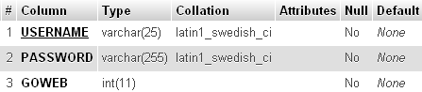

Figure 7. LOGIN Table

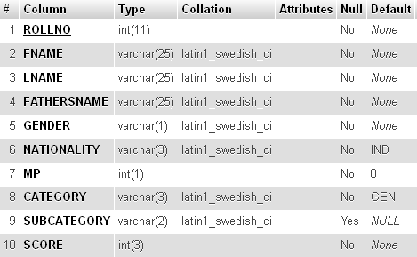

Figure 8. CET_STUDENT Table

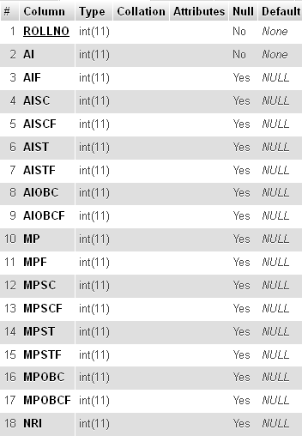

Figure 9. RANK Table

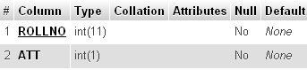

Figure 10. ATTENDANCE Table

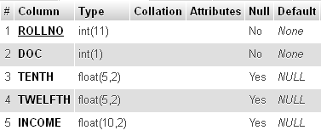

Figure 11. DOCUMENT Table

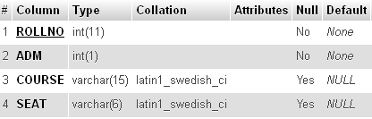

Figure 12. COURSE Table

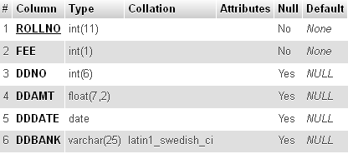

Figure 13. FEES Table

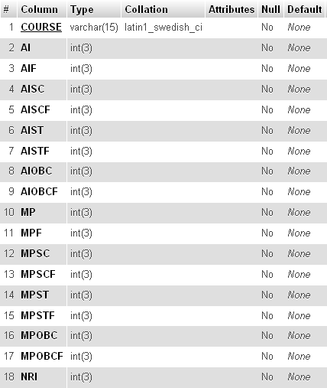

Figure 14. SEATS Table

**INPUT OUTPUT DESIGN**

For any system to work properly it is very necessary to keep a check over the input and output of the system. In this system, we have used relational database management system (MySQL) for storing and sending information. So, it imposes an additional constraint that the data inputted by the user should conform to the standards for insertion of data into database. For example, the 10th and 12th percentage attribute should only contain float numbers not characters and should not be greater than 100.

**USER INTERFACE DESIGN**

Any project how so ever good it may become failure if the end user, it is meant to cater cannot user it. For the end user to reap full benefits of the project, the project should have a good interface. Interface is the way a project links with the end user; it accepts the inputs from the user and gives output to the user. For a project, to be successful it should have a clean and understandable interface.

Properties of good interface are as follows:

* It should not be too bright in colors.
* The text written should be clear.
* Proper labeling should be done on labels and buttons.
* Proper warnings should be provided to the user at all levels.

**TEST PLAN**

Before implementing any system it is properly tested in order to verify that it conforms to its specifications and will meet the user requirements. The development of the software systems involves a series of production activities where opportunities for injection of human fallibilities are enormous. Errors may begin to occur at the very inception of the process where the objectives may be enormously or imperfectly specified, as well as in later design and development stages. Because of human inability to perform and communicate with perfection, software development accompanies quality assurance activity. Software testing is critical element of software quality assurance and represents the ultimate review of specification, design and coding.

Testing objectives are as follows:

* Testing is a process of executing or running a program with the intention of finding an error.
* A successful test is on that uncovers an as yet undiscovered error.
* A good test case is one that has a high probability of finding a yet undiscovered error.

The testing process usually commences with a test plan. Test plan is a general document for the entire project that defines the scope, approach to be taken and the schedule of testing as well as identifies the test items for the entire testing process and the personnel responsible for the different activities of testing. The test planning can be done in parallel with coding and design phases. It specifies the levels of testing and the units that need to be tested. For each of the different units first the test cases are specified and then they are reviewed. An important factor while forming a unit is the testability of a unit. A unit should be such that it can be easily tested, in other words it should be possible to form meaningful test cases and execute that unit without much effort with these test cases. During the test case execution phase, the test cases are executed, and various reports are produced for evaluating testing.

**TEST CRITERIA**

The approach for testing specifies the overall approach to be followed in the current project. Since the project is a dummy one, all the testing has been done with dummy data. Some of the testing conditions have been shown using screenshots. The testing has been done in two ways:

* Module Testing: Here the individual modules (web pages) were tested for errors. For example, as soon as the login page was designed it was parallel tested along side by side. Then when attendance page was designed it was parallel tested along side by side and so on.
* Comprehensive Testing: The various modules (web pages) were first integrated as single software and then testing is done for checking the discrepancies that may occur while the software is running.

**SOFTWARE QUALITY ASSURANCE**

* Adaptability: Since the counseling portal will be made with top priority that it should be easy to use and perform most of the complex jobs on its own. So, it will be easy to adapt as there will be nothing in this project that will confuse the user.
* Availability: This project will be totally based on web pages. So, if the server is connected to internet, then the project can be used from any part of the world using internet.
* Portability: The software will be portable as it works on web browsers. And web browser can work on many platforms whether it is Windows, Linux, Mac OS, etc.
* Reliability and Robustness: The software will be reliable as many facilities will be provided for checking the data redundancy, data integrity and data security, etc. This software will be robust as many error handling functions will be included in this software.
* Accuracy: Most of the data entries will be in form of checkbox, combo box and radio buttons. So in these cases, wrong data entry cannot happen. And in case of textboxes, they will be checked twice. Firstly, using JavaScript, then if by chance JavaScript cannot detect wrong data entry, then again data is checked by RDBMS.
* Maintainability and Testability: The software will be very easy to maintain. As in counseling, same procedure is to be followed for each and every student. And using few student data, the software can be tested for errors and the errors can be debugged.

**SCREEN SHOTS**

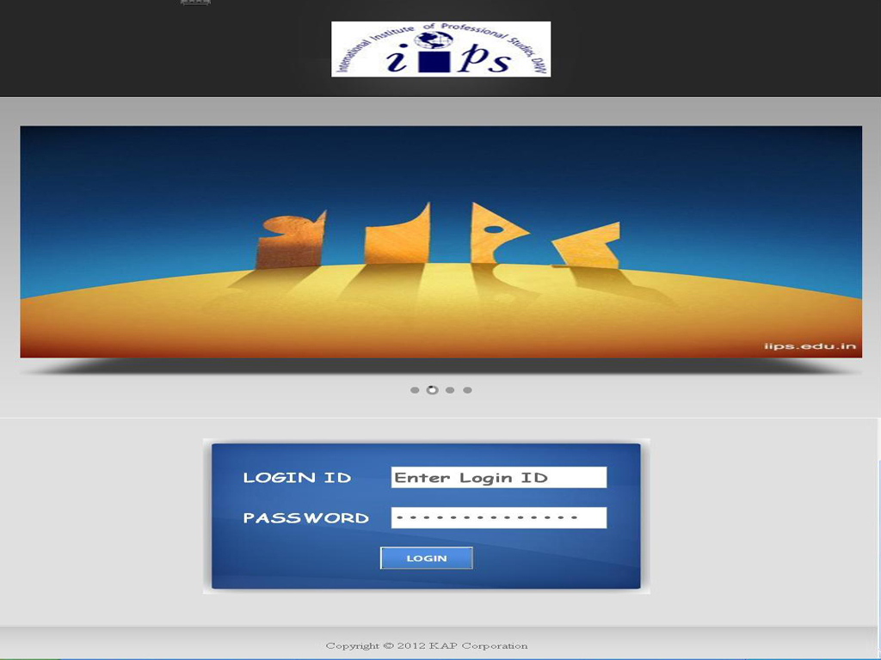

Figure 15. LOGIN WEB PAGE

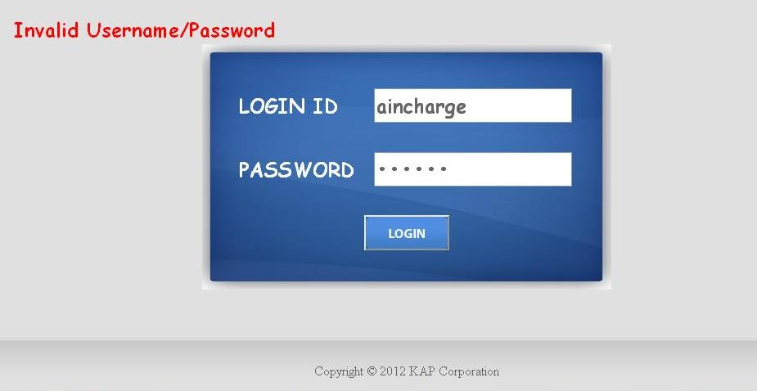

Figure 16. LOGIN WEB PAGE

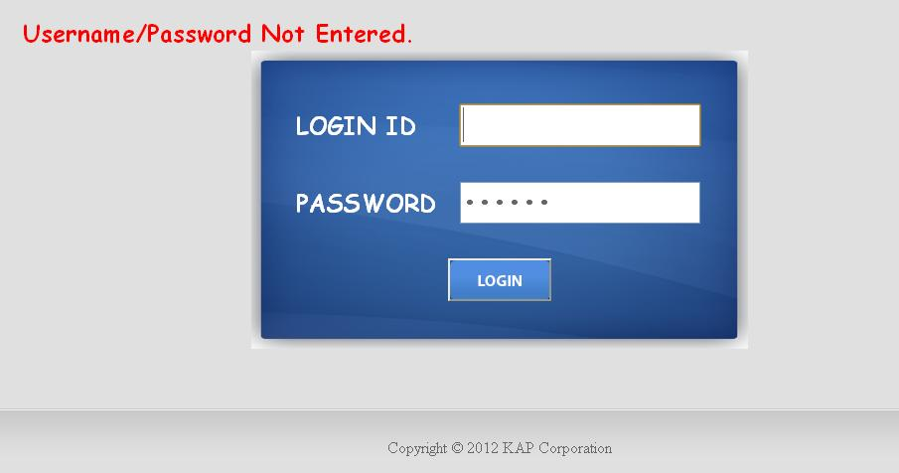

Figure 17. LOGIN WEB PAGE

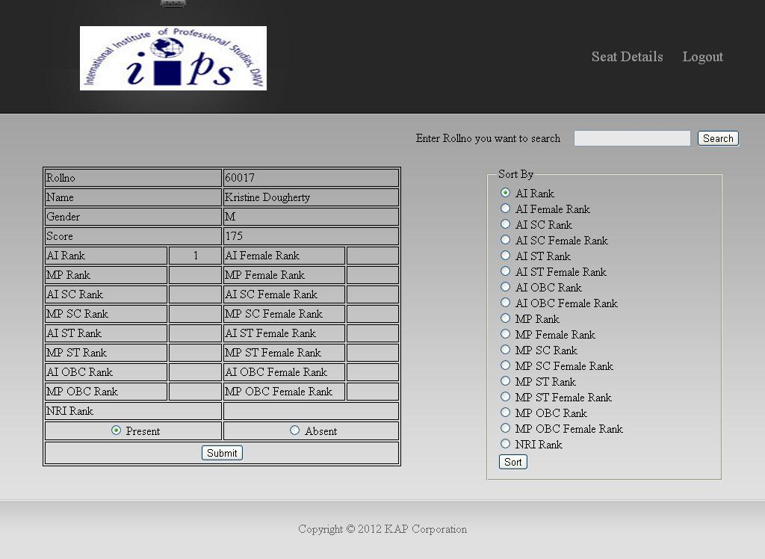

Figure 18. ATTENDANCE WEB PAGE

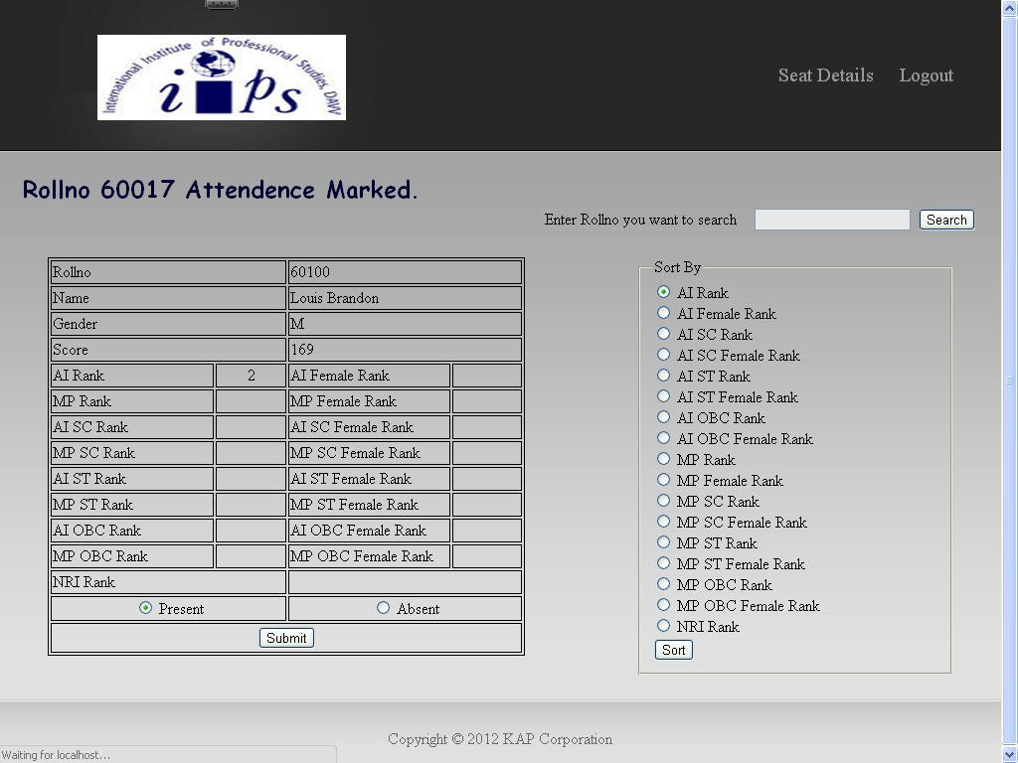

Figure 19. ATTENDANCE WEB PAGE

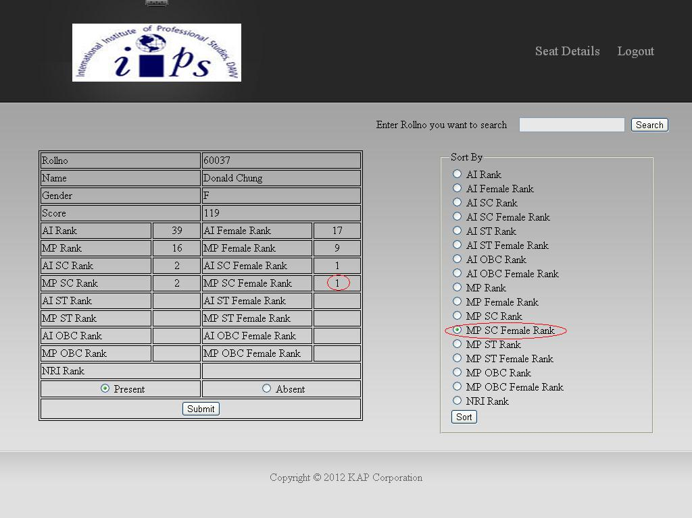

Figure 20. ATTENDANCE WEB PAGE

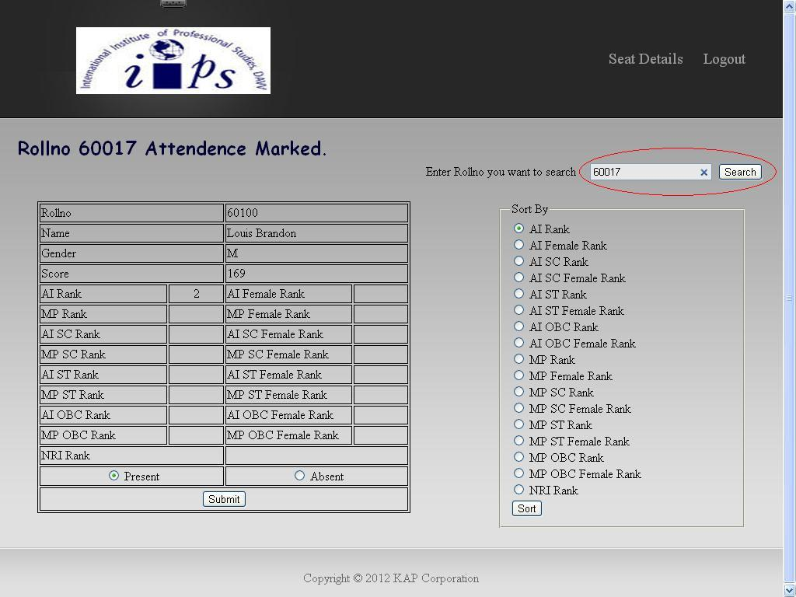

Figure 21. ATTENDANCE WEB PAGE

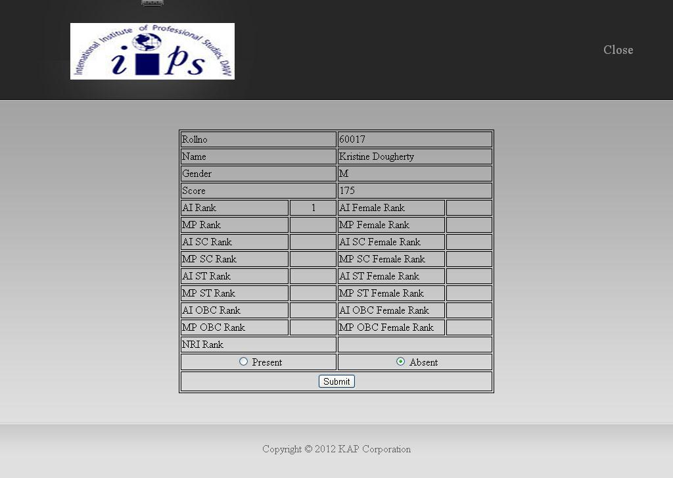

Figure 22. ATTENDANCE SEARCH WEB PAGE

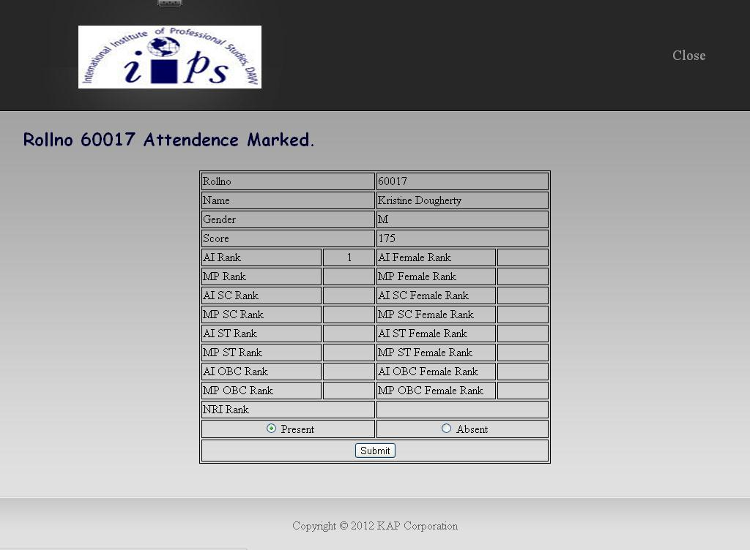

Figure 23. ATTENDANCE SEARCH WEB PAGE

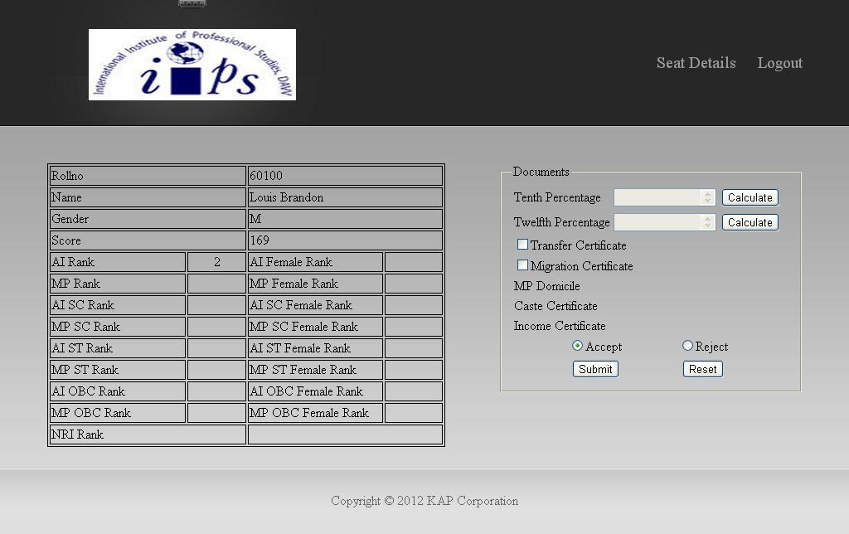

Figure 24. DOCUMENT WEB PAGE

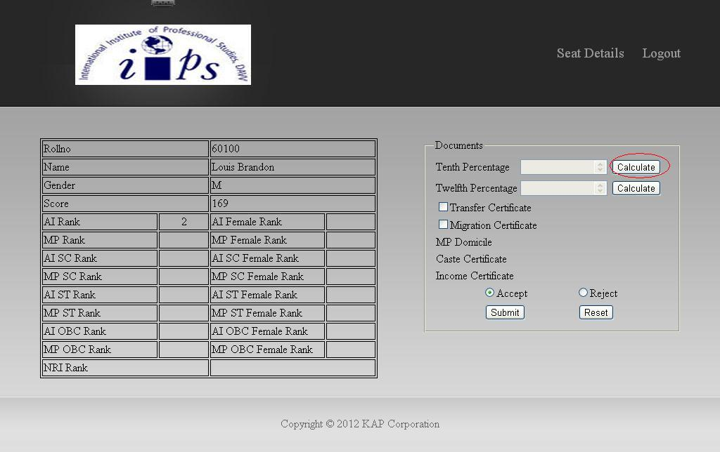

Figure 25. DOCUMENT WEB PAGE

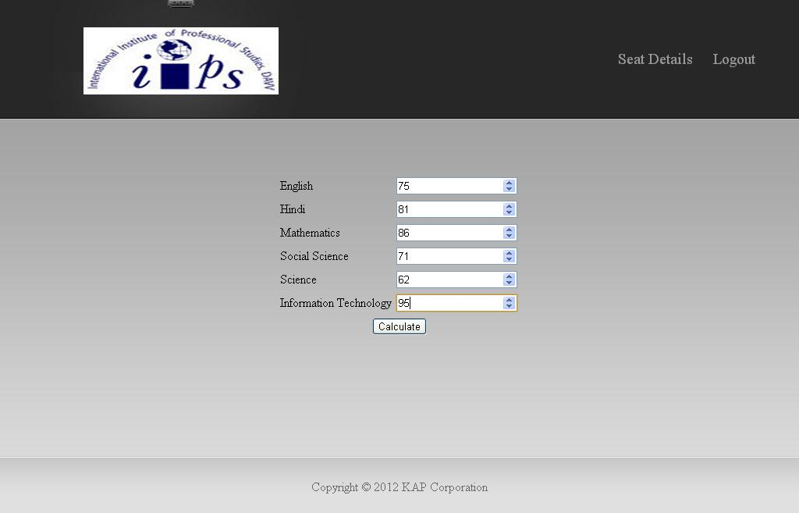

Figure 26. DOCUMENT WEB PAGE

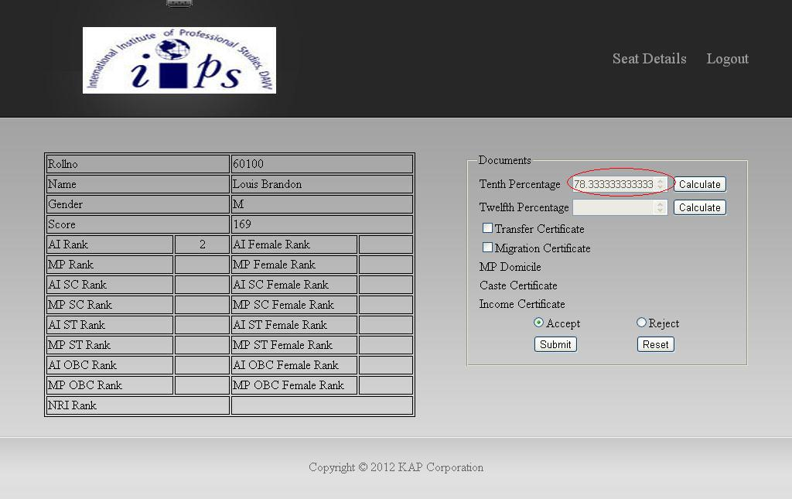

Figure 27. DOCUMENT WEB PAGE

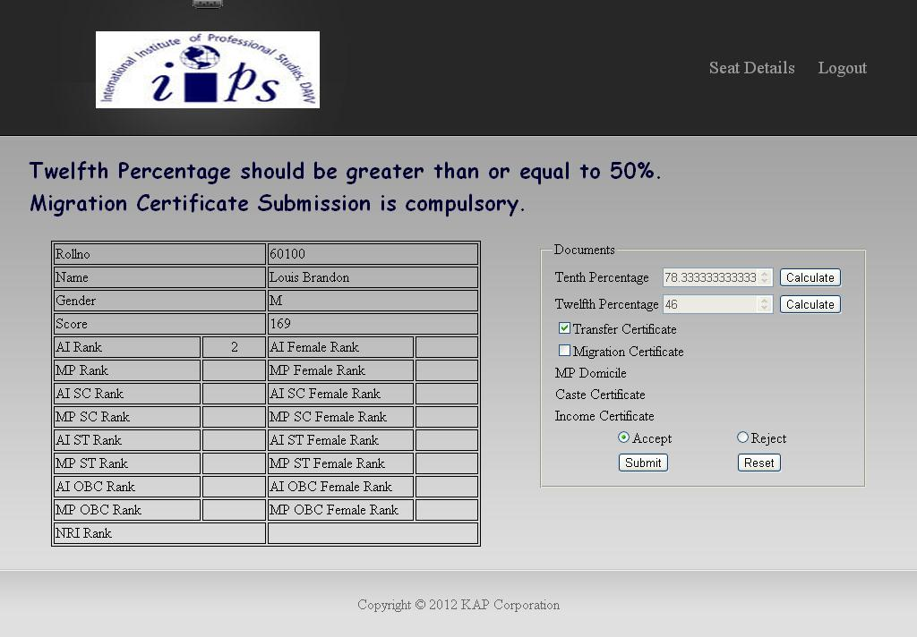

Figure 28. DOCUMENT WEB PAGE

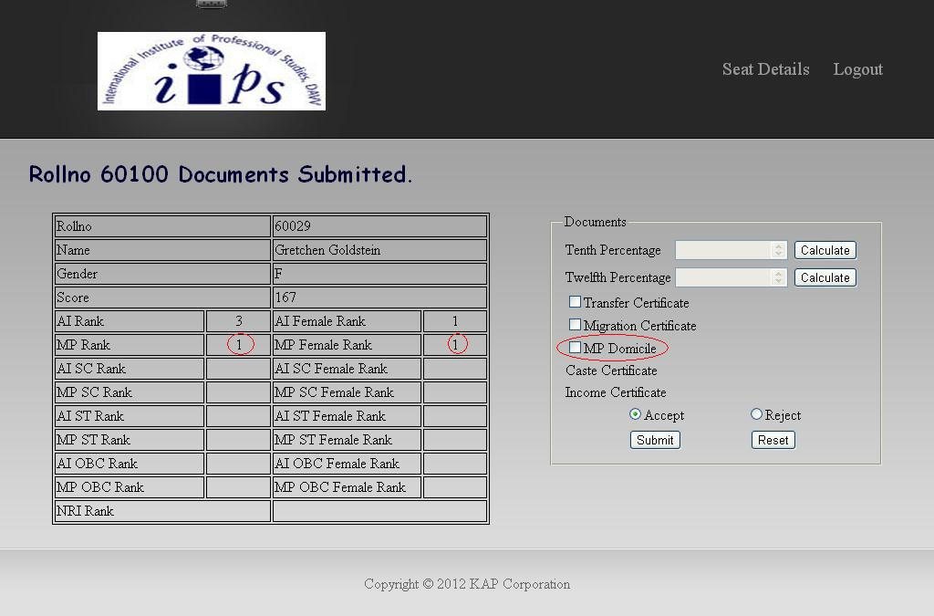

Figure 29. DOCUMENT WEB PAGE

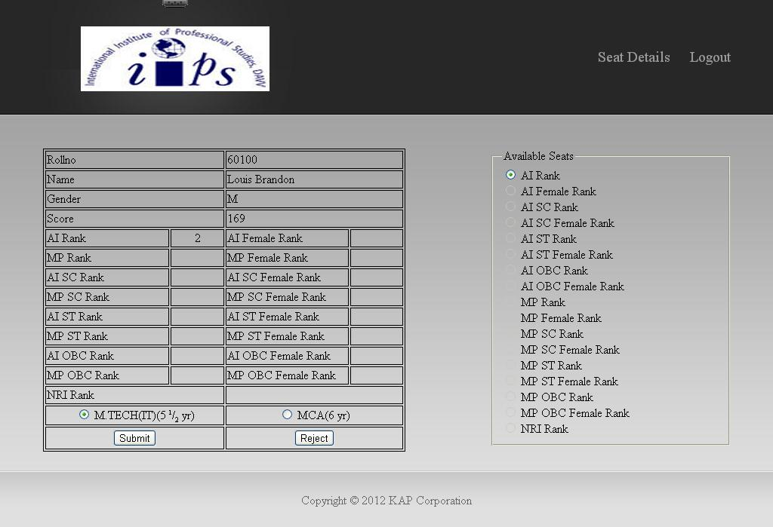

Figure 30. COURSE WEB PAGE

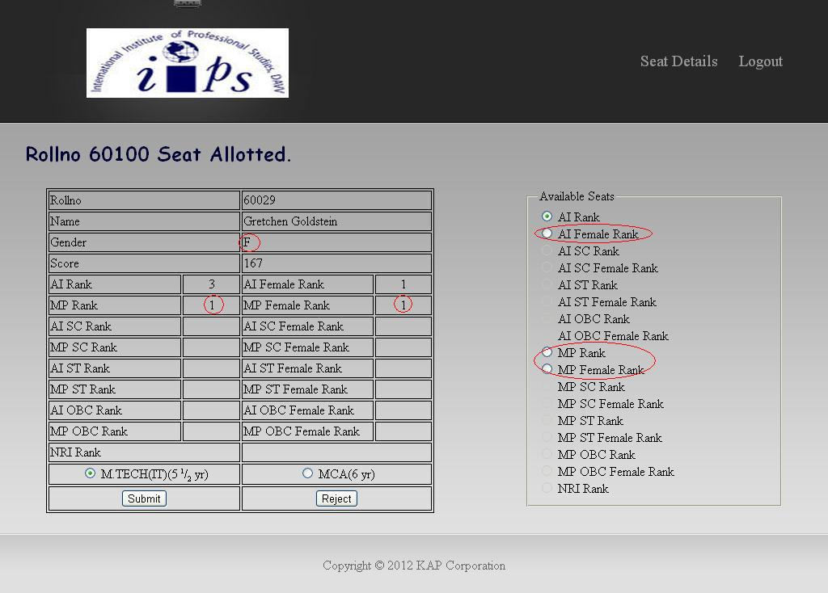

Figure 31. COURSE WEB PAGE

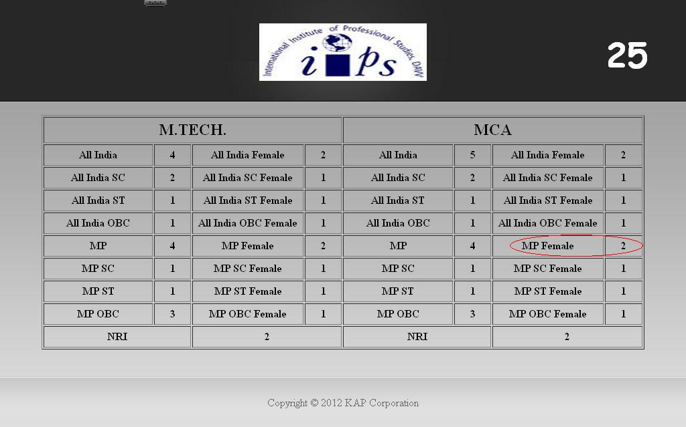

Figure 32. SEATS WEB PAGE

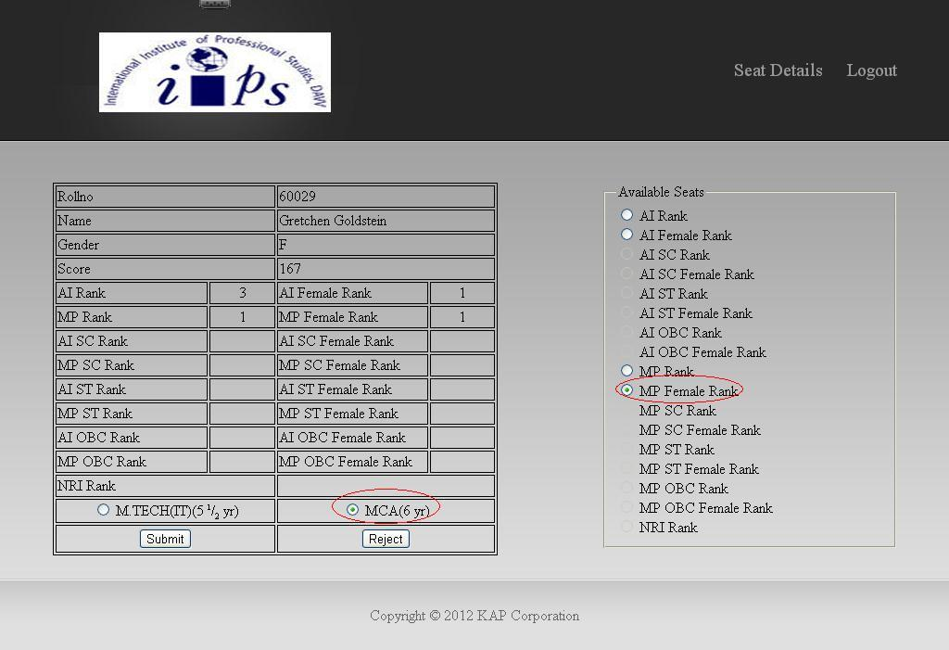

Figure 33. COURSE WEB PAGE

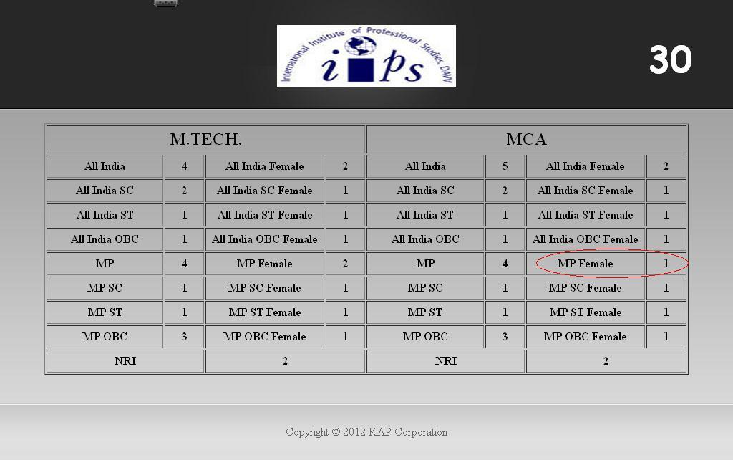

Figure 34. SEATS WEB PAGE

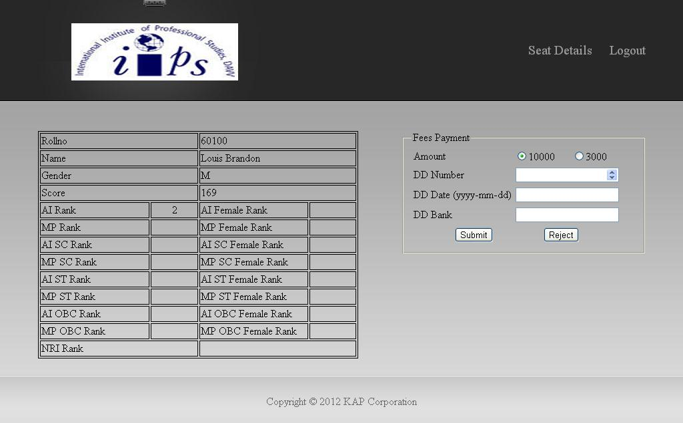

Figure 35. FEES WEB PAGE

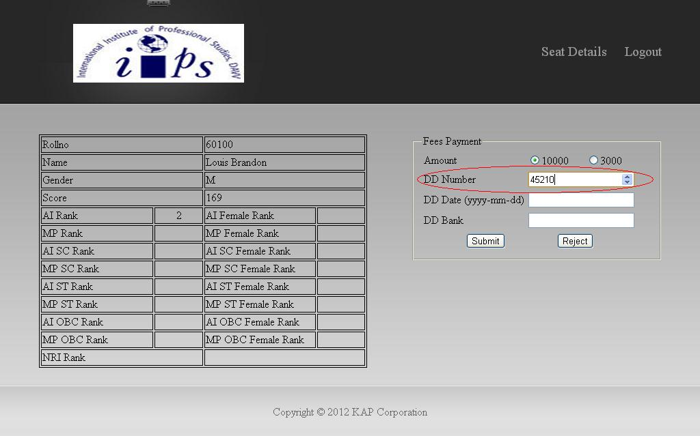

Figure 36. FEES WEB PAGE

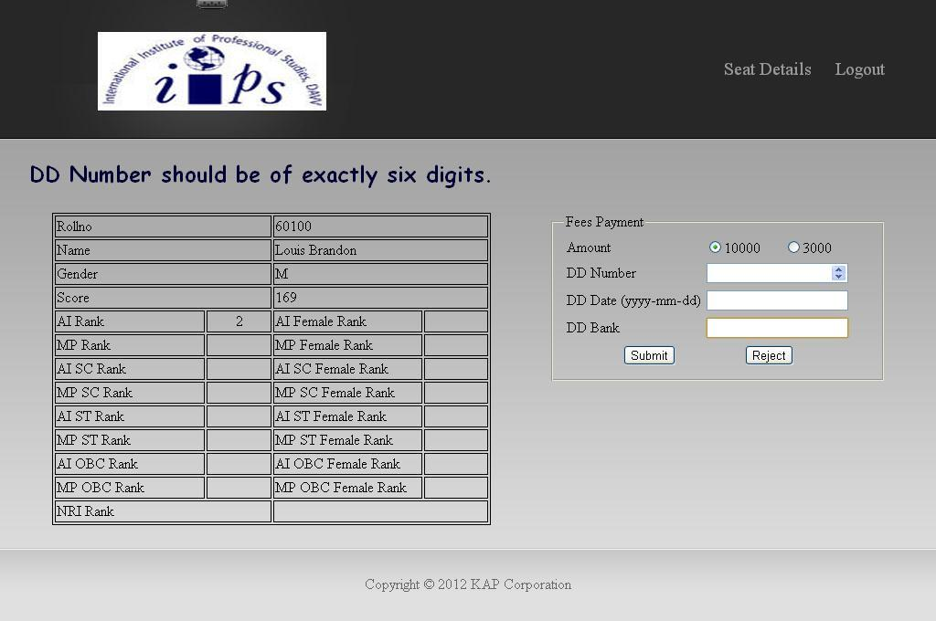

Figure 37. FEES WEB PAGE

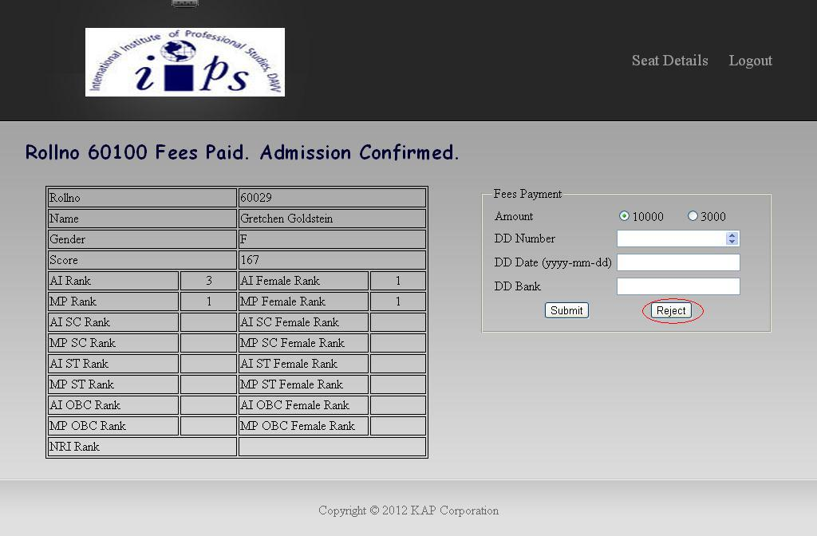

Figure 38. FEES WEB PAGE

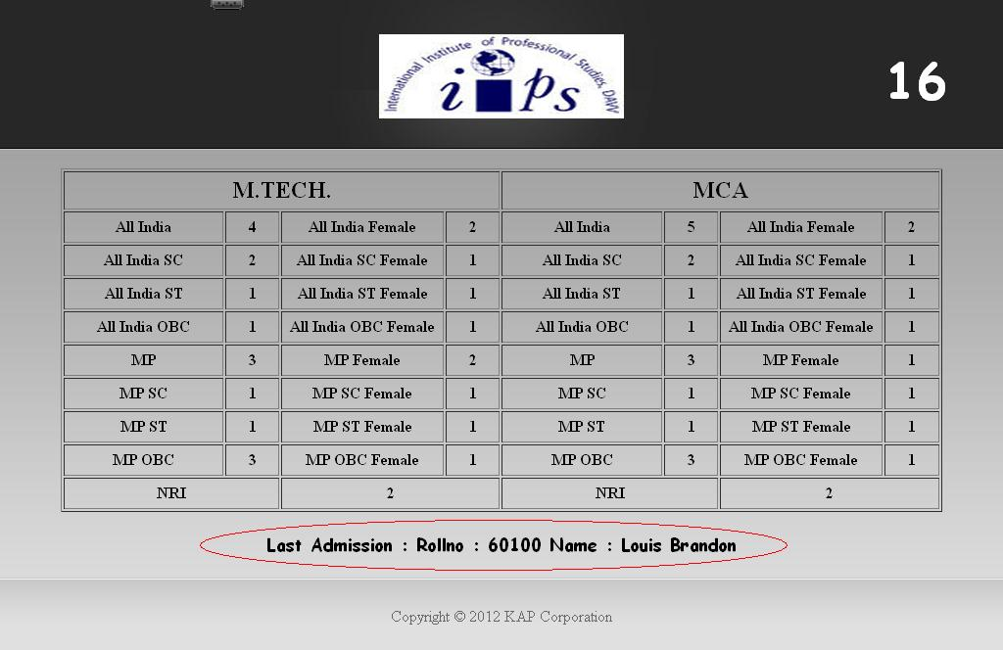

Figure 39. SEATS WEB PAGE

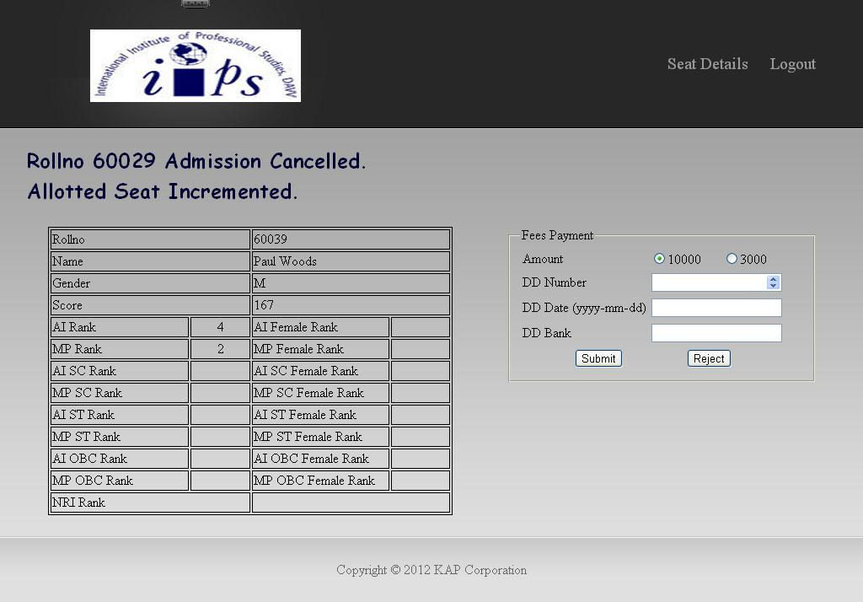

Figure 40. FEES WEB PAGE

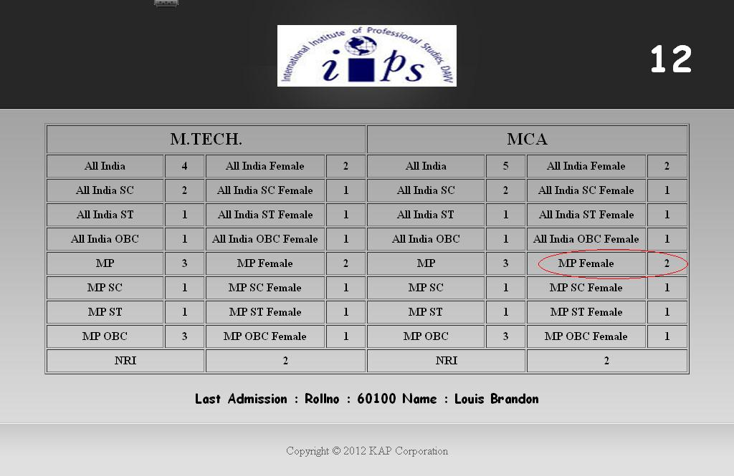

FIGURE 41. SEATS WEB PAGE

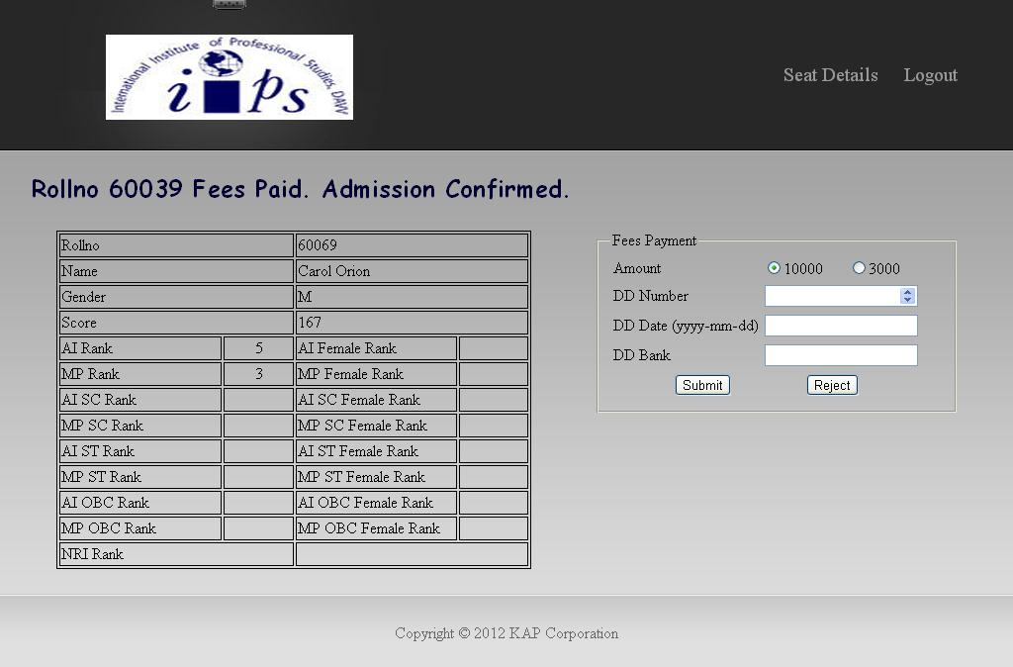

Figure 42. FEES WEB PAGE

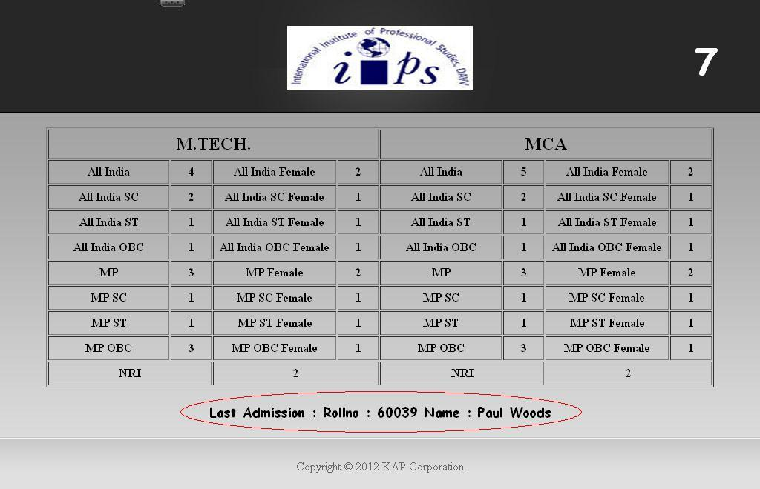

Figure 43. SEATS WEB PAGE

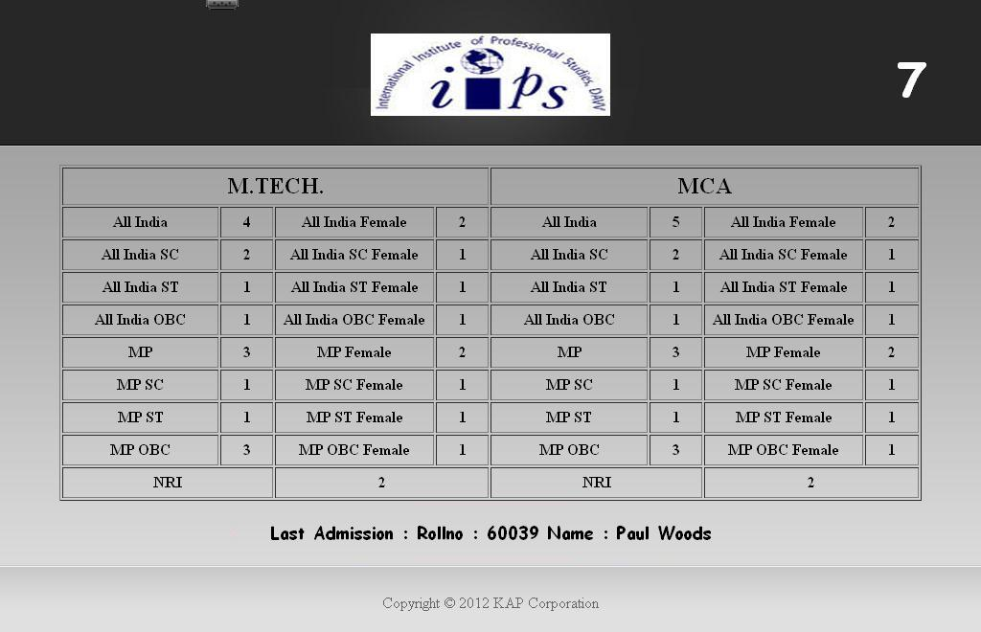

Figure 44. SEATS WEB PAGE

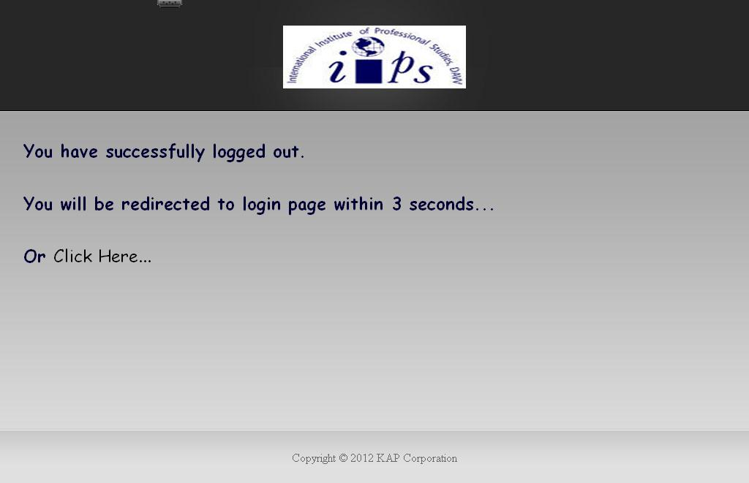

Figure 45. LOGOUT WEB PAGE

**CONCLUSION**

As a first major project done by us, it would remain a lifetime achievement to us for our future course of action. We have gained a lot of new thing & experience while doing this project work. The tools being used under the project provided us with an approach to solve any problem.

The platform of the project was quite interesting & challenging. It helped us in carving our technical as well as creative skills.

**BOOKS AND MANUALS**

* System Analysis And Design by Elias M. Awad
* Programming PHP by Rasmus Lerdorf and Kevin Tatroe
* Practical PHP Programming by Paul Hudson
* Learning MySQL by Sehed Tahaghoghi and Hugh Williams
* MySQL (4th Edition) by Paul DuBois

**WEB RESOURCES**

* www.google.com
* www.answers.yahoo.com
* www.w3schools.com
* www.stackoverflow.com
* www.go4expert.com